

INSERT YOUR SCHOOL’S LOGO HERE

Build Your Future by Helping Others with a Career as a
CERTIFIED FINANCIAL PLANNER™ Professional

“Becoming a CFP® Pro will equip you with the knowledge that you need.”

Matt Aaron, CFP®

Go to CFPpro.org to watch Brittney’s video and learn more about financial planning.

5
FACTS ABOUT FINANCIAL PLANNING

Freedom and flexibility.
Talk to successful CFP® professionals and you will learn that what they value the most in their work is the ability to balance personal and professional lives.

It’s not all about math.
CFP® professionals help people take a holistic, “big picture” look at their finances to help them reach their life goals.

Not a one-size-fits-all career.
From striking out on your own to working at firms big and small, there are a variety of career pathways for CFP® professionals.

A rewarding career helping others.

This exciting career brings personal satisfaction of helping others, as well as financial rewards. According to the Bureau of Labor Statistics, median pay for financial planners is $89K.

A profession in demand.
Job growth for financial advisors is expected to grow 4 times higher than other occupations, according to the Bureau of Labor Statistics.




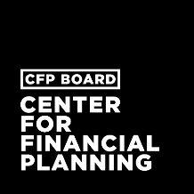
Founding Sponsors
Lead Founding Sponsor
“I am a CFP® Pro” campaign is made available by:
Interested in a career in financial planning?
Contact [school contact name and title] at [contact info] to learn more about our [program name].

